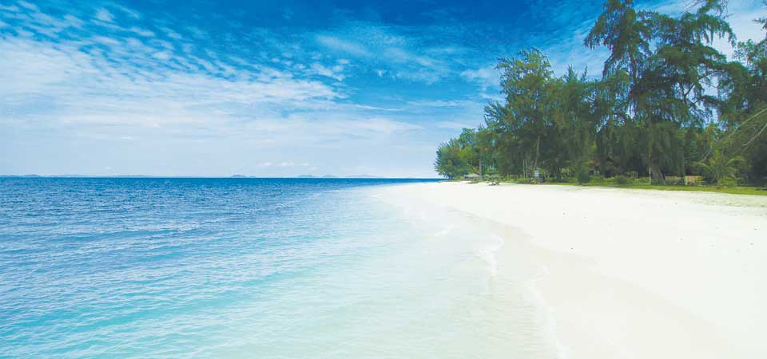
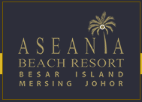
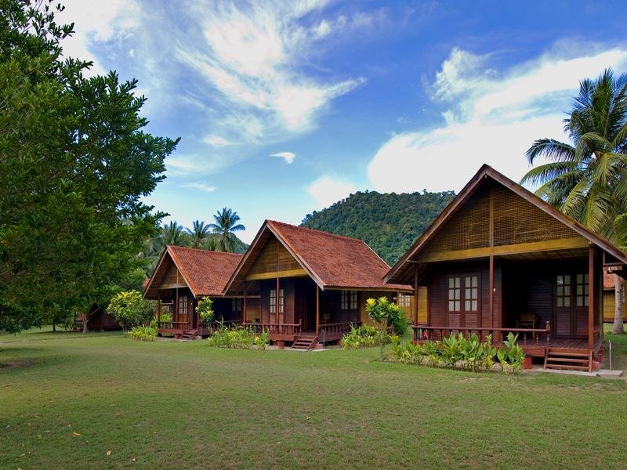
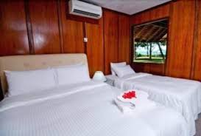

MCO DEAL – 3D2N Aseania Beach Resort, Besar Island
With white powdery sand and turquoise-blue waters Aseania Resort Pulau Besar, Mersing, Johor assures a great vacation for all guests. The island too is very rich in flora and fauna with forests which are millions of years old. Guests can also enjoy kilometres of contiguous beach lines with romantic swaying palms. Fun seekers can enjoy Island Hopping, snorkelling, jungle trekking and all other sea and beach sports. Or you can just relax in comfortable lounges at the beach or by the swimming pool while sampling our signature cocktails. Our 46 well-furnished chalet, meanwhile will ensure that your stay here will be as comfortable as possible. The chalets include air-conditioning, hot/cold shower, mini bar and other comforts. The comfortable verandas offer you a vantage area where you can sit-back and enjoy the scenery – the beach and the sea or the gardens and mountains.
To preserve this unspoilt beauty the government has made the Island a gazette Marine Park. This protects the very rich species of marine life and their underground wonders within 2 nautical miles of the island
Packages Rate (Check in date: 1 July 2020 - 15 Oct 2020 & 1 Mac 2021 - 15 Oct 2021)
Full Board Packages | 3 Days 2 Nights
Chalet Category | Twin / Triple Share | Child (4-11 Yrs old)
Country View | RM 298 / per person | RM 150 / per person
Sea View | RM 368 / per person | RM 150 / per person
Packages Excluded
- Marine Park Fees of RM10 per pax (Malaysian) / RM 36 per pax (Foreigner).
- Tourism Tax RM10 Per Room Per Night
- Personal Expenses
Add on Snorkelling: RM 70/Adult, RM 45/Child
(Minimum 6 person)
Packages Included
- 2 Way Return Mersing – Resort Ferry Transfer
- 2 Nights Accommodation Stay at Aseania Resort
- Meals: 2 Breakfast

**Maximum number of occupancies in a Chalet is 3 Adult or 2 Adult + 2 child (below 11 years old)
**infant below (0-3years old) FOC

Boat Transfer
From Mersing Jetty to Resort 12.30pm
From Resort to Mersing Jetty 10.30am
Note: Ferry transfer is subject to weather and sea conditions, resort management reserves the right to change timing accordingly.

Special Request:
BBQ Dinner min 30 Person and additional charges RM 80.00 per person prior to advance booking.
OPTIONALS & ACTIVITIES: (subject to availability) update:15.06.2020
Island Hopping / Snorkelling / Fishing Trip / Kayak / Jungle Trekking / Pool Table / Beach Ball / Team Building / Corporate and Function / Wedding Events **Please refer to resort office for the above-mentioned optional services

CHECK IN / CHECK OUT TIME
Check In: 1.00pm (early check in is possible if rooms are available)
Check Out: 10.30am or earlier if departure boat is earlier
Any request for check-out time extension will be subject to room availability and management discretion
If extend check out time to / after 6.00pm, subject to one night’s room charge

