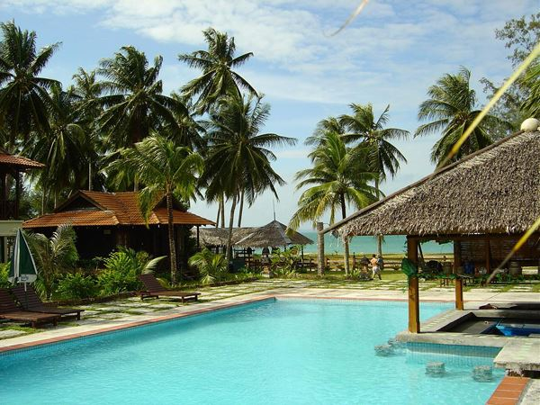
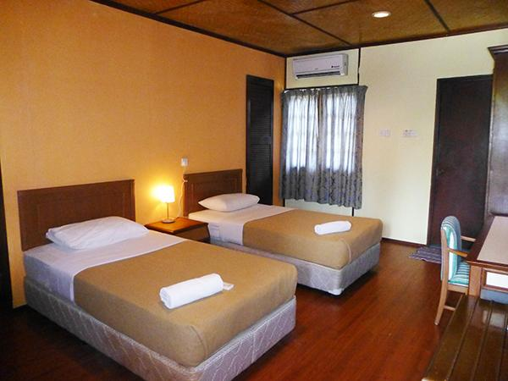
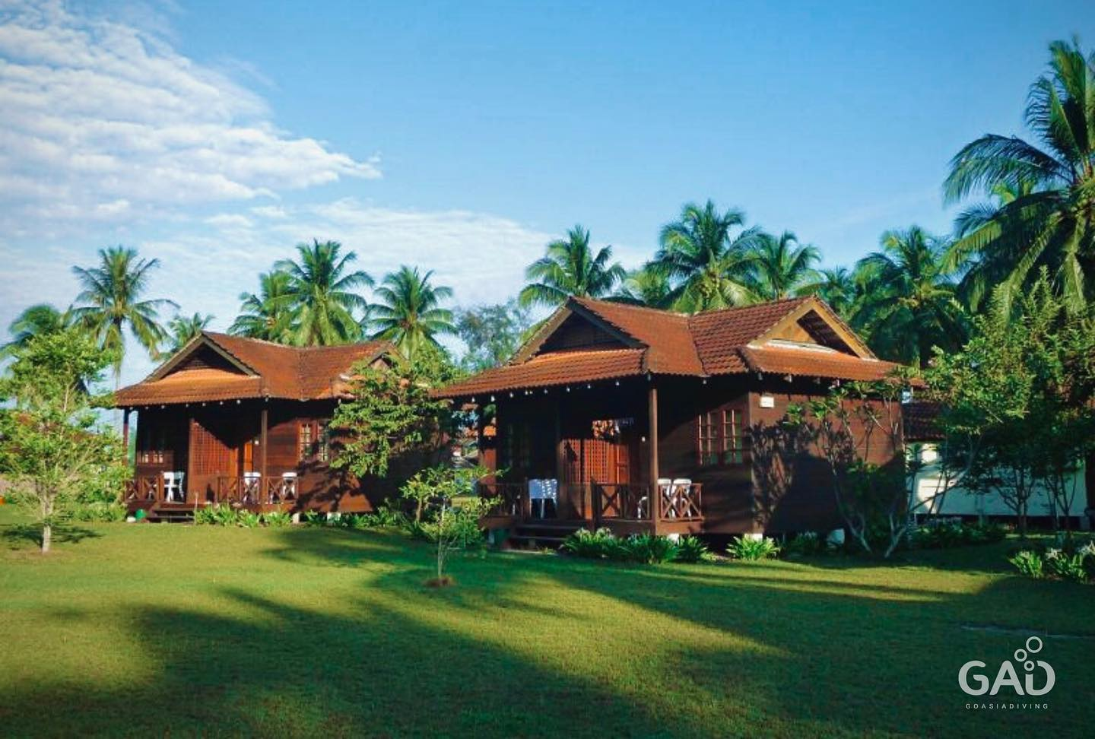
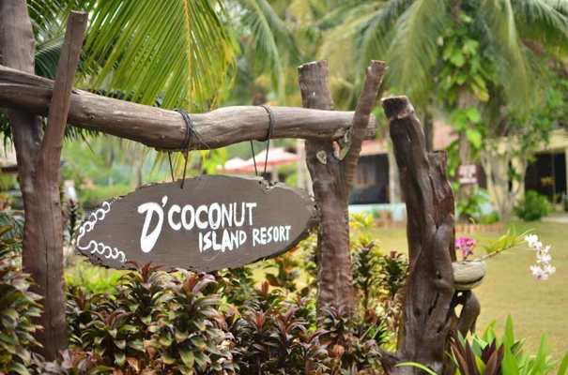

2020 RMCO PROMOTION D’ COCONUT ISLAND RESORT, PULAU BESAR
PACKAGE RATES 2020
(Valid from 15 Jun – 31 Oct 2020)
OFF - PEAK SEASON (Per Person)
FIT RATES | 2 Days 1 Night |  |  |  | 3 Days 2 Nights
 | Deluxe | Family | Standard | Exec Deluxe | Deluxe | Family | Standard | Exec Deluxe
Single | RM 460 | N/A | RM 425 | RM 490 | RM 615 | N/A | RM 565 | RM 670
Twin | RM 350 | N/A | RM 320 | RM 385 | RM 510 | N/A | RM 460 | RM 565
Triple | RM 330 | RM 340 | RM 300 | RM 365 | RM 490 | RM 500 | RM 435 | RM 545
Quad | RM 310 | RM 320 | RM 280 | RM 340 | RM 470 | RM 480 | RM 415 | RM 520
Child below ( 4-11) | RM 215 | RM 220 | RM 195 | RM 230 | RM 305 | RM 310 | RM 270 | RM 340
Extend 1 Night (P.P) | N/A | N/A | N/A | N/A | RM 150 | RM 160 | RM 130 | RM 170
(Surcharge RM 40 /per person for Weekend (FRI & SAT), School & Public Holidays and Eve. (My /SIN)
BOAT TIMING: IN: 12.30PM / OUT: 10.30 AM ONLY

PACKAGE INCLUDES:
- Welcome drink
- Accommodation in air-conditioned rooms
- Boat transfer ( Mersing/P.Besar/Mersing)
- Meals: (1B / 1L / 1D - per night stay)
- Complimentary Jungle or Beach Trekking (1-2 hours)
- Free flow of hot beverages ie. Coffee & tea only (Excluding bottle water, alcoholic & carbonated drinks)
PACKAGE EXCLUDES:
- Marine Park Fees of RM10/pax(Domestic) / RM30/pax (Foreigner). Payable to Marine Authorities at Mersing Jetty (subject to change without prior notice)
- Tourism Tax (Foreigner) RM 10 per room per night
- Any expenses of personal nature

CHILDREN RATE (4-11 years old)
- Children sharing room with 1 Adult - One of the child will be charge full Twin Adult rate
- If Children not sharing with Adults - two children will be charge full Twin Adult rate
- Child below 4 years old is FOC(without mattress)

OPTIONALS & ACTIVITIES:
- Snorkeling Trip (Around 2 hours): Enquire rates at the Resort.
Update as 15.06.2020
- BBQ Dinner (for groups more than 40 persons): RM30 per person

ELECTRICITY:
- Please be inform that there will be a daily 3 hour power cut off (3pm – 6pm) for the off peak month for February, March & October.
- There will be 24hours electricity from April to September unless due to unforeseen and uncontrollable circumstances

CHECK IN / CHECK OUT TIME
- Check In: 2.00pm (early check in is possible if rooms are available)
- Check Out: 10.00am or earlier if departure boat is earlier
- Any request for check-out time extension will be subject to room availability and management discretion
- If extend check out time to / after 3.00pm, there will be a nominal charge of RM100 per room
TERMS AND CONDITIONS
- All confirmed bookings must be paid in full before the expiry of the payment deadline given. Upon the expiry of the deadline, the booking will be automatically cancelled without any further notice.
- In the event of cancellation of bookings after full payment was remitted, the following cancellation policies applies :-
- More than 1 month to arrival date : Full Refund less Admin Fees (5%) of total value
- 3 weeks or more to arrival date : 70% Refund less Admin Fees (5%) of total value
- 2 weeks or more to arrival date : 50% Refund less Admin Fess (5%) of total value
- Less than 2 weeks : NO Refund
- NO REFUND will be made in whole or in part for any unused days or unconsumed food at the Resort resulting from late arrival or premature departure. Confirmed guests who do not show up will be charged in full and no refund will be made for whatever reasons.
- REVISION of rates is subject to resort discretion and without prior notice.

D Coconut Pulau Besar Resort
Pulau Besar Mersing Johor

Seasonal Surcharge Calendar 2020
 | Jun | Jul | Aug | Sep | Oct
Sunday
Monday | 1
Tuesday | 2 |  |  | 1
Wednesday | 3 | 1 |  | 2
Thursday | 4 | 2 |  | 3 | 1
Friday | 5 | 3 |  | 4 | 2
Saturday | 6 | 4 | 1 | 5 | 3
Sunday | 7 | 5 | 2 | 6 | 4
Monday | 8 | 6 | 3 | 7 | 5
Tuesday | 9 | 7 | 4 | 8 | 6
Wednesday | 10 | 8 | 5 | 9 | 7
Thursday | 11 | 9 | 6 | 10 | 8
Friday | 12 | 10 | 7 | 11 | 9
Saturday | 13 | 11 | 8 | 12 | 10
Sunday | 14 | 12 | 9 | 13 | 11
Monday | 15 | 13 | 10 | 14 | 12
Tuesday | 16 | 14 | 11 | 15 | 13
Wednesday | 17 | 15 | 12 | 16 | 14
Thursday | 18 | 16 | 13 | 17 | 15
Friday | 19 | 17 | 14 | 18 | 16
Saturday | 20 | 18 | 15 | 19 | 17
Sunday | 21 | 19 | 16 | 20 | 18
Monday | 22 | 20 | 17 | 21 | 19
Tuesday | 23 | 21 | 18 | 22 | 20
Wednesday | 24 | 22 | 19 | 23 | 21
Thursday | 25 | 23 | 20 | 24 | 22
Friday | 26 | 24 | 21 | 25 | 23
Saturday | 27 | 25 | 22 | 26 | 24
Sunday | 28 | 26 | 23 | 27 | 25
Monday | 29 | 27 | 24 | 28 | 26
Tuesday | 30 | 28 | 25 | 29 | 27
Wednesday |  | 29 | 26 | 30 | 28
Thursday |  | 30 | 27 |  | 29
Friday |  | 31 | 28 |  | 30
Saturday |  |  | 29 |  | 31
Sunday |  |  | 30
Monday |  |  | 31
X | Dates Surcharge Applies

