Date | Time | Program
Day 1 | 07.00pm | JOHOR BAHRU – MERSING/ TG GEMOK – TIOMAN ( Dinner )  Proceed to MERSING JETTY by own,  Meet at JETTY For FERRY to TIOMAN Island -Lunch by own  Arrived at TIOMAN – Check-in Resort – Free activities, Beach Games, Have Fun!  Dinner provided
Day 2 | 09.00am | TIOMAN ISLAND ( Breakfast / Lunch / Dinner )  Breakfast – Get Ready For “ BOAT OUTING ” – equip yourself for Snorkeling  (Ringgis Island & Marine Park include Mask & Life Jacket)  Return back to resort for lunch after snorkeling trip  Back to Resort – more beach games / swim / sit back & relax  Dinner provided
Day 3 |  | TIOMAN – MERSING – JOHOR BAHRU ( Breakfast )  Breakfast – Check – out , FERRY Transfer back to MERSING  Journey home
Basic Package Includes: -
PAYA BEACH RESORT (RMCO 2020)

GO TIOMAN ISLAND 2020 3Day2Night
2 Way Mersing – TIOMAN /TG GEMOK – Mersing Ferry Transfer
2 Nights Accommodation at Paya Beach Resort
2 Breakfast / 1 Lunch / 2 Dinner
1 Boat Outing (Snorkeling) Trip (Snorkeling Equipment Mask & Life Jacket included)
PAYA BEACH RESORT | TWIN | TRIPLE | QUAD | SINGLE | CHILD
Standard Chalet | RM 565 | RM 475 | RM 435 | RM 874 | RM 250
Superior Chalet | RM 595 | RM 495 | RM 455 | RM 934 | RM 250
Superior Pool View | RM 615 | RM 515 | RM 465 | RM 974 | RM 250
Standard Chalet (Beach Front) | RM 635 | RM 535 | RM 475 | RM1,034 | RM 250
Superior Chalet (Beach Front) | RM 675 | RM 575 | RM 515 | RM1,114 | RM 250
Deluxe Suite Chalet (Beach Front) | RM 775 | RM 625 | RM 555 | RM1,264 | RM 250
Deluxe Chalet (Beach Front) | RM 795 | RM 635 | RM 565 | RM1,304 | RM 250
Surcharge - Every Friday &  (07Jun - 23Aug)（02 Aug-31 Aug） Expect 31July | RM 30 / ROOM / NIGHT
Surcharge - Every Saturday & 26-31July | RM 60 / ROOM / NIGHTS
*Public holiday surcharge ( Malaysia /Sin )  16 Sep | RM 30 Adult / RM15 Child ( Per Package )
*Public holiday surcharge ( Malaysia /Sin)  31July, 09, 20 & 30 Aug, 24 & 29 Oct | RM 50 Adult / RM25 Child ( Per Package )
Package Exclude : Marine Park conservancy fees payable in :
: Malaysian RM 5/ Adult, RM 3/ Child ; Foreigner RM 30/ Adult, RM 15/Child
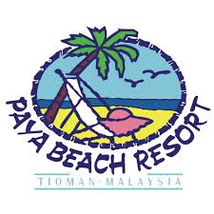 Johor National park -Ex Mersing : Malaysian RM 5/ Adult, RM 3/ Child ; Foreigner RM 20/ Adult, RM 10/Child
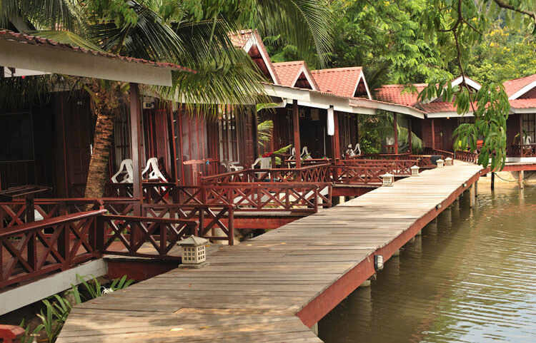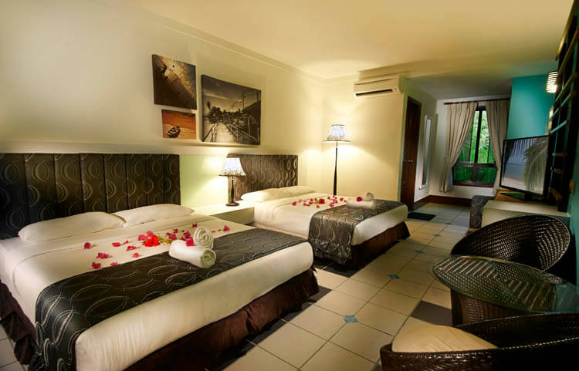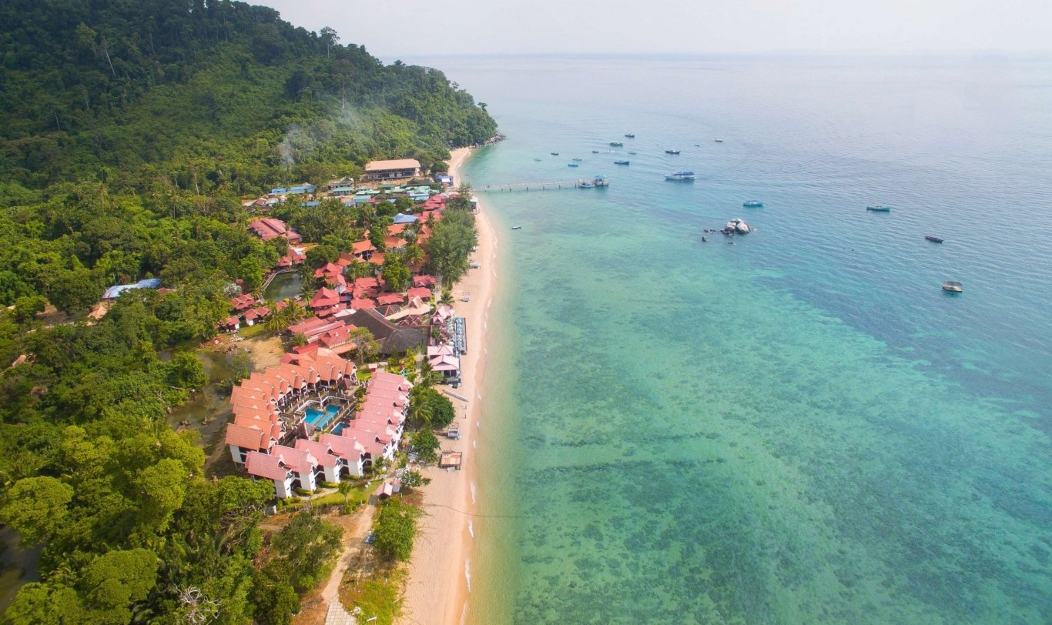

Child Information | Bus Transfer
Child No Bed 2 – 11 years old | J.Bahru – Mersing & V.V Bus | RM 90 per pax
 | J.Bahru – Mersing & V.V Bus | RM 1,900 per bus

More Information, please log on:
www.vacation-hub.com
Update as 09.06.2020
康誠旅行社私人有限公司(Co. No. 111996-V KKKP: 0611)
Vacation Hub Travel & Tours Sdn Bhd
Tel: 07-520 7119 WhatsApp’s: 016-716 7886 /016-733 1816
Email: inbound@vacation-hub.travel

More Information, please log on:
www.vacation-hub.com

