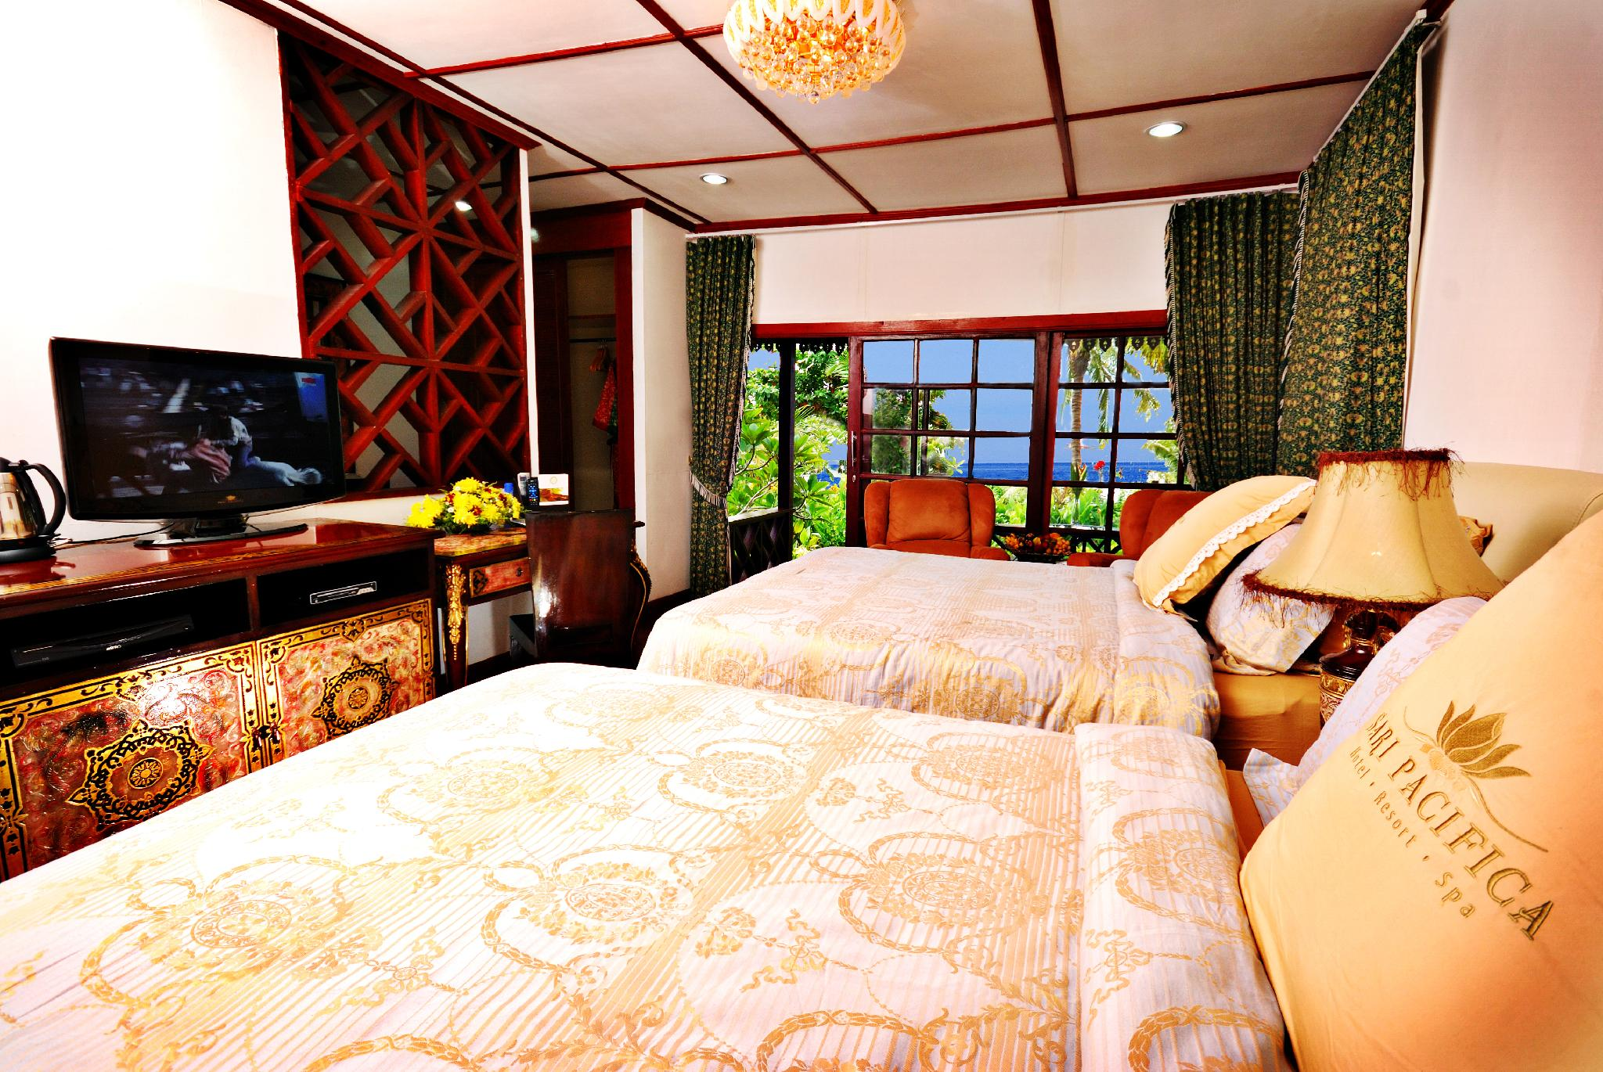
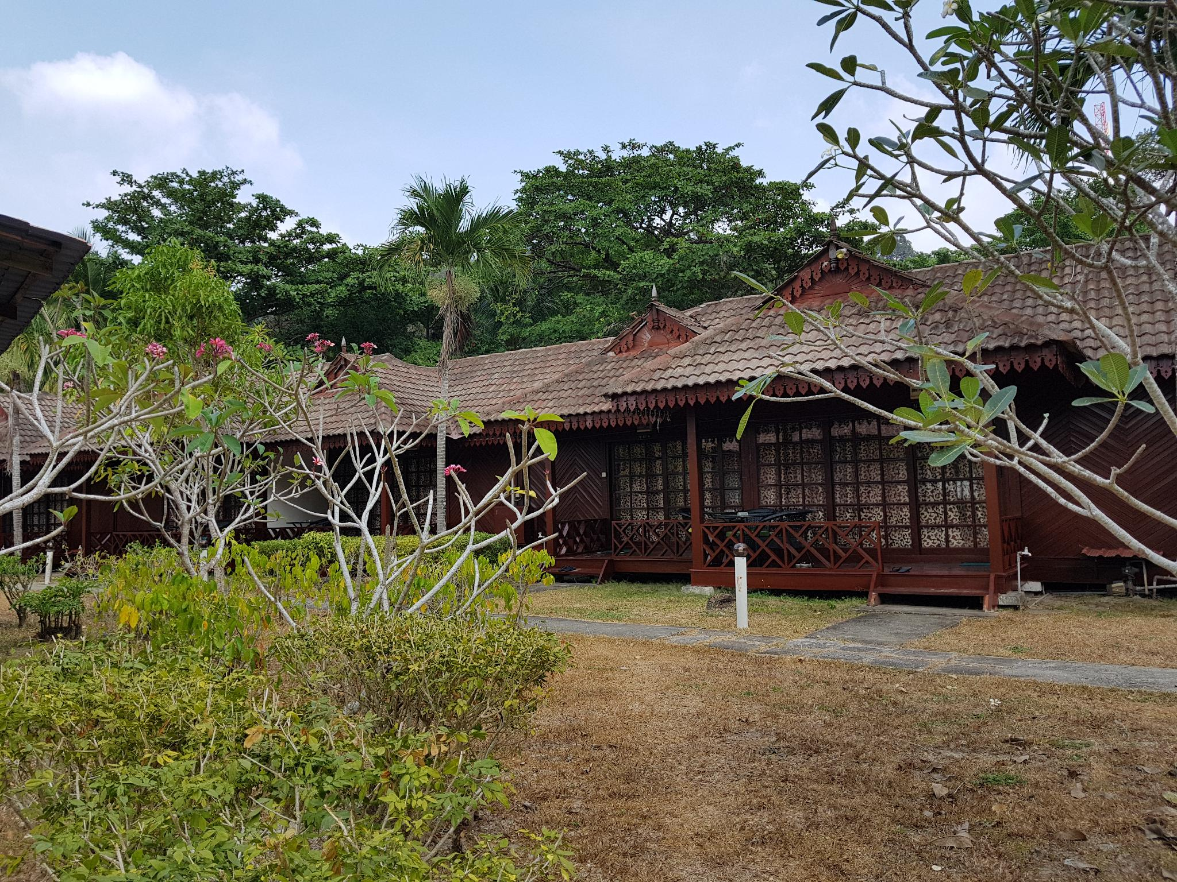
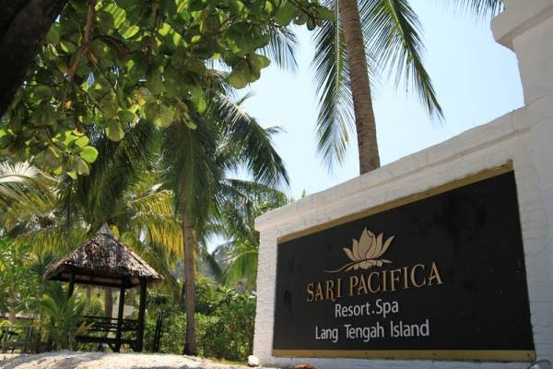
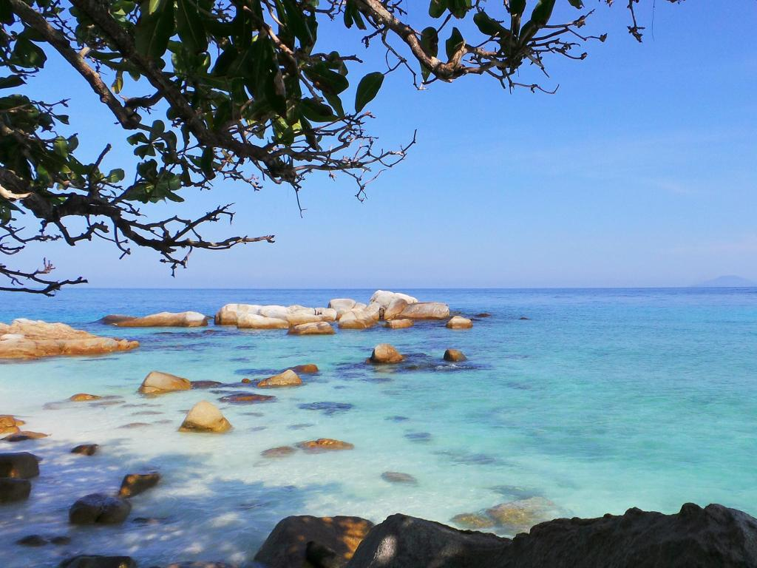

RMCO DEAL -3D2N Sari Pacifica Lang Tengah Island
Welcome to Sari Pacifica Resort Lang Tengah, an elegant resort located at Lang Tengah Island about half hour’s boat ride from Kuala Terengganu
Sari Pacifica Resort Lang Tengah is in the midst of the best kept marine park on the east coast of Malaysia with one of the best breathtaking diving and snorkelling site in Malaysia.
This boutique resort hotel in Lang Tengah Island has two different categories of rooms – Villas built in the rustic local traditional Malaysian “Kampung Style” architecture for your idyllic accommodation in Lang Tengah Island and basic room built on two level buildings within the compound of this lovely resort.
All resort villas feature elegant interior fittings with modern entertainment outfits to make your stay as exciting and memorable as the magnificent natural beauty of the island itself. All basic room have hot and cold showers, air-conditioning and it has three single beds.
Package Rates 2020 (Valid from 1st July 2020 to 07th October 2021)
Full board Package | 3Days 2 Nights Packages （Promotion Rate）
Chalet Category | Twin /Triple sharing | Child (4-11 yrs old)
Garden Villa | RM 380 / per person | RM 190/ per person
Pool Villa | RM 480 /per person | RM 190 /per person
Budget Room | RM 300/ per person | RM 190/ per person
Package Include:  - 2 Way Return Merang – Resort Ferry Transfer  - Accommodation Stay at Sari Pacifica Resort, Lang Tengah Island  - Meals: 2 Breakfast only | PACKAGE EXCLUDES:  - Marine Park Fees of RM10 per pax (Malaysian) / RM35 per pax (Foreigner).  - Tourism Tax RM 10 per room per night  - Any expenses of personal nature  - Snorkeling RM 75/Adult ; RM 48/Child(4-11yrs old)
Remarks :Garden View & Budget room maximum 3 person in a room
/ Pool view -maximum 4 adults or 2 adult +2child in a room.
*Infant 0-3years old FOC
Boat Transfer
From Merang Jetty to Resort 08.00am, 10.00am, 01.00pm & 03.00pm (Subject to weather)
From Resort to Merang Jetty 09.00am, 12.00pm & 04.00pm (Subject to weather)

Charted a Boat at the following charges :
Per boat ( maximum 8 person) per way – RM 530 / Per boat (maximum 14 person) per way – RM 848
Per boat (maximum 30 person) per way – RM 1378
Note: Ferry transfer is subject to weather and sea conditions, resort management reserves the right to change timing accordingly.
Airport transfer (Kuala Terengganu airport – Merang Jetty – Kuala Terengganu airport)
Seat in coach per way -RM 28/ per pax
Charter a Van (maximum 4 person) per way – RM 106
Charter a Van (maximum 8 person) per way – RM 160

