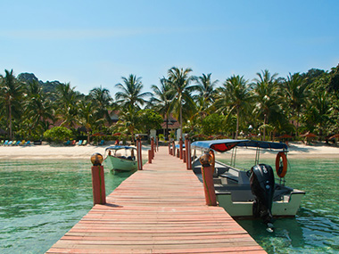
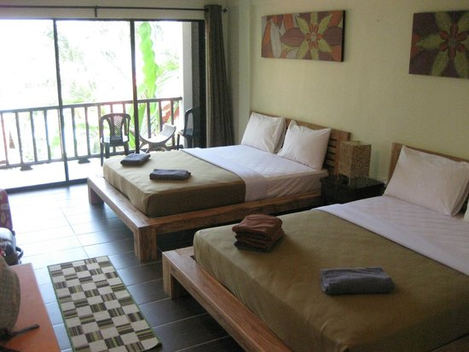
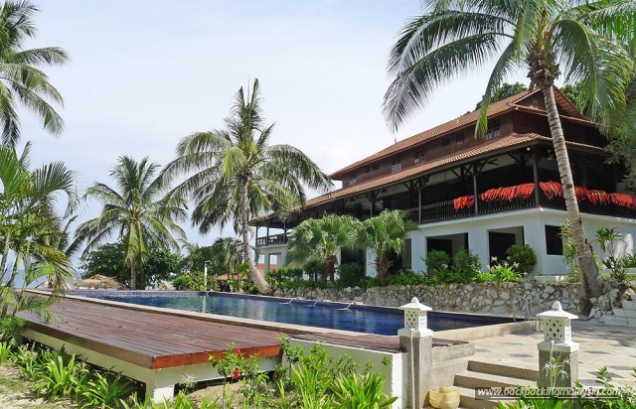

2020 RMCO PROMOTION D’ COCONUT LAGOON, LANG TENGAH
PACKAGE RATES 2020
3 Days 2Night Package
OFF - Peak Season (Valid from Jun 15 - Oct 29, 2020)
Per Person Rate | East Wing |  |  |  | West Wing
 | Standard | Superior | Deluxe Low | Deluxe High | Exec Standard | Exec Deluxe | Family(4Pax) | Cabanas
SINGLE | RM 510 | RM 590 | RM 640 | RM 670 | RM 705 | RM 735 | N/A | RM 850
TWIN | RM 405 | RM 485 | RM 530 | RM 565 | RM 600 | RM 630 | N/A | RM 670
TRIPLE | RM 385 | RM 465 | RM 510 | RM 545 | RM 580 | RM 605 | N/A | RM 650
QUAD | N/A | RM 435 | RM 485 | RM 515 | RM 560 | RM 580 | RM 590 | N/A
Child(4-11) | RM 240 | RM 290 | RM 320 | RM 335 | RM 365 | RM 380 | RM 385 | RM 400
Extend 1Night | RM 170 | RM 185 | RM 205 | RM 205 | RM 215 | RM 215 | RM 225 | RM 235
(Surcharge RM 40 /per person for Weekend (FRI & SAT ) ,School & Public Holidays and Eve. (My /SIN)
BOAT TIMING : IN : 10.00 AM / OUT : 12.00 PM ONLY
PACKAGE INCLUDES:
- Welcome drink
- Boat transfer ( Merang/P.Lang Tengah/Merang)
- Meals: (2B / 2L / 2D ) & each extension night entitles 1B/1L/1D
- Free flow of hot beverages ie. Coffee & tea only (Excluding alcoholic & carbonated drinks)
- Complimentary 2 snorkeling Trips around Lang Tengah (excluding equipments). Not applicable for extension stay.
PACKAGE EXCLUDES:
- Snorkeling equipment rental for mask/snorkel (RM10/day) & Life Vest (RM10/day)
- Marine Conservation Fees of RM5 (Malaysian) ; RM 30 (Foreigner). Subject to change.
- Tourism Tax (Foreigner) RM 10 per room per night
- Any expenses of personal nature

CHILDREN RATE (4-11 years old)
- Children sharing room with 1 Adult - One of the child will be charge full Twin Adult rate
- If Children not sharing with Adults - two children will be charge full Twin Adult rate

OPTIONALS & ACTIVITIES:
- Snorkeling Trip (Around 2 hours): Enquire rates at the Resort.
- BBQ Dinner (for groups more than 40 persons) : RM30 per person
- 02 way KT Airport -Merang Jetty transfer -RM 70 Per head (SIC basis-45minutes ride ) flight before 8am
- 02 way KT Bus Station -Merang Jetty transfer -RM 75 Per head (SIC basis-75minutes ride )
Update as 15.06.2020
ELECTRICITY:
- Please be inform that there will be a daily 3 hour power cut off (3pm – 6pm) for the off peak month for February, March & October.
- There will be 24hours electricity from April to September unless due to unforeseen and uncontrollable circumstances

CHECK IN / CHECK OUT TIME
- Check In: 2.00pm (early check in is possible if rooms are available)
- Check Out: 10.30am or earlier if departure boat is earlier
- Any request for check-out time extension will be subject to room availability and management discretion
- If extend check out time to / after 3.00pm, there will be a nominal charge of RM100 per room
TERMS AND CONDITIONS
All confirmed bookings must be paid in full before the expiry of the payment deadline given. Upon the expiry of the deadline, the booking will be automatically cancelled without any further notice.
- In the event of cancellation of bookings after full payment was remitted, the following cancellation policies applies :-
- More than 1 month to arrival date : Full Refund less Admin Fees (5%) of total value
- 3 weeks or more to arrival date : 70% Refund less Admin Fees (5%) of total value
- 2 weeks or more to arrival date : 50% Refund less Admin Fess (5%) of total value
- Less than 2 weeks : NO Refund
- NO REFUND will be made in whole or in part for any unused days or unconsumed food at the Resort resulting from late arrival or premature departure. Confirmed guests who do not show up will be charged in full and no refund will be made for whatever reasons.
- REVISION of rates is subject to resort discretion and without prior notice.

D Coconut Lagoon
Pulau Lang Tengah, Terengganu

Seasonal Surcharge Calendar 2020
 | Jun | Jul | Aug | Sep | Oct
Sunday
Monday | 1
Tuesday | 2 |  |  | 1
Wednesday | 3 | 1 |  | 2
Thursday | 4 | 2 |  | 3 | 1
Friday | 5 | 3 |  | 4 | 2
Saturday | 6 | 4 | 1 | 5 | 3
Sunday | 7 | 5 | 2 | 6 | 4
Monday | 8 | 6 | 3 | 7 | 5
Tuesday | 9 | 7 | 4 | 8 | 6
Wednesday | 10 | 8 | 5 | 9 | 7
Thursday | 11 | 9 | 6 | 10 | 8
Friday | 12 | 10 | 7 | 11 | 9
Saturday | 13 | 11 | 8 | 12 | 10
Sunday | 14 | 12 | 9 | 13 | 11
Monday | 15 | 13 | 10 | 14 | 12
Tuesday | 16 | 14 | 11 | 15 | 13
Wednesday | 17 | 15 | 12 | 16 | 14
Thursday | 18 | 16 | 13 | 17 | 15
Friday | 19 | 17 | 14 | 18 | 16
Saturday | 20 | 18 | 15 | 19 | 17
Sunday | 21 | 19 | 16 | 20 | 18
Monday | 22 | 20 | 17 | 21 | 19
Tuesday | 23 | 21 | 18 | 22 | 20
Wednesday | 24 | 22 | 19 | 23 | 21
Thursday | 25 | 23 | 20 | 24 | 22
Friday | 26 | 24 | 21 | 25 | 23
Saturday | 27 | 25 | 22 | 26 | 24
Sunday | 28 | 26 | 23 | 27 | 25
Monday | 29 | 27 | 24 | 28 | 26
Tuesday | 30 | 28 | 25 | 29 | 27
Wednesday |  | 29 | 26 | 30 | 28
Thursday |  | 30 | 27 |  | 29
Friday |  | 31 | 28 |  | 30
Saturday |  |  | 29 |  | 31
Sunday |  |  | 30
Monday |  |  | 31
X | Dates Surcharge Applies

