3 Days/4 Days Tenggol Island Beach Resort (RMCO)

2020 GO TENGGOL ISLAND
Date | Time | Itinerary
DAY 1 | 07.30 am  07.00 pm | Dungun Jetty–Tenggol island（Lunch/Dinner）  Assemble at Dungun Jetty . Take boat transfer to Tenggol island.  Arrival Tenggol island & check in resort .Lunch at resort .free & easy.  Night time dinner prepared by resort .
DAY2 |  | Tenggol island （Breakfast/ Lunch/ Dinner）  After breakfast. Start 1st Snorkelling Trip. Tenggol Island is part of a group of islands within the southern regions of the Terengganu Marine Park. There are numerous beautiful beaches, and also a few paths that cross the 3 by 2km island.Non-divers could enjoy some snorkeling around the island.  After lunch. Proceed for 2nd Snorkelling Trip.  Night time dinner prepared by resort .free&easy
DAY 3  （4D3N PACKAGES） |  | Tenggol island （Breakfast/ Lunch/ Dinner）  After breakfast. Start 3rd Snorkelling Trip.  Lunch at resort  Night time dinner prepared by resort .free&easy
DAY3/  DAY 4 | 11.30 am | Tenggol island –Dungun Jetty （Breakfast ）  After breakfast ,check out resort .Take boat transfer back to Dungun Jetty.
PACKAGES INCLUDE ：
- 02 Way Boat Transfer ：Dungun Jetty 〉Tenggol Island 〉Dungun Jetty （1 hour boat ）
- Accommodation
- Meals : 1 Breakfast ，1 Lunch , 1 Dinner per day
- Snorkeling trip with equipment

Travel period : 01/03/2020-31/10/2020
3D2N SNORKELLING PACKAGES  （2 SNORKELLING TRIPS） | WEEKDAY ( SUNDAY -THURSDAY ) |  | WEEKEND （FRIDAY -SATURDAY )
 | TWIN | TRIPLE | TWIN | TRIPLE
Superior Room | RM 790 | RM 718 | RM 930 | RM 845
Superior Seaview Room | RM 948 | RM 862 | RM 1115 | RM 1014
4D3N SNORKELLING PACKAGES  （3SNORKELLING TRIPS） | WEEKDAY ( SUNDAY -THURSDAY ) |  | WEEKEND （FRIDAY -SATURDAY )
 | TWIN | TRIPLE | TWIN | TRIPLE
Superior Room | RM 1020 | RM 926 | RM 1199 | RM 1112
Superior Seaview Room | RM 1199 | RM 1099 | RM 1438 | RM 1308
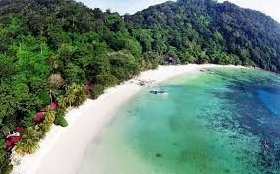
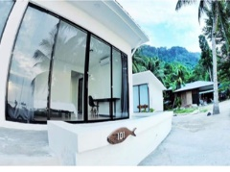
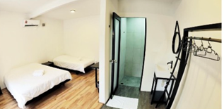
*Price inclusive 6%SST
Boat Transfer Timing ：
Dungun Jetty > Tenggol island : 08.30am
Tenggol Island > Dungun Jetty : 10.30am

Remarks ：**Foreigner Toursim tax @ RM 10 /per room /per night

